Supplementary information

Targeted delivery of mycophenolic acid to the mesenteric lymph node using a triglyceride mimetic prodrug approach enhances gut-specific immunomodulation in mice

Ruby Kochappan1,2, Enyuan Cao1,2,Sifei Han1,2*, Luojuan Hu1,2, Tim Quach2,3, Danielle Senyschyn1,2,Vilena Ivanova Ferreira1,2, Given Lee1,2, Nathania Leong1, Garima Sharma1 , Shea Fern Lim2,3, Cameron J. Nowell4, Ziqi Chen5, Ulrich H. von Andrian5, Daniel Bonner6, Justine D. Mintern7, Jamie S. Simpson3,6,Natalie L Trevaskis1*, Christopher J.H. Porter1,2*

1 Drug Delivery, Disposition and Dynamics, Monash Institute of Pharmaceutical Sciences, Monash University, Melbourne, Victoria, 3052, Australia

2 ARC Centre of Excellence in Convergent Bio-Nan-o Science and Technology, Monash Institute of Pharmaceutical Sciences, Monash University, Melbourne, Victoria, 3052, Australia

3 Medicinal Chemistry, Monash Institute of Pharmaceutical Sciences, Monash University, Melbourne, Victoria, 3052, Australia

4 Drug Discovery Biology, Monash Institute of Pharmaceutical Sciences, Monash University, Melbourne, Victoria, 3052, Australia

5 Dept. of Immunology, Harvard Medical School and Ragon Institute of MGH, MIT and Harvard, 77 Ave. Louis Pasteur, Boston, MA 02115

6 PureTech Health, 6 Tide Street, Boston, MA, 02210, USA

7 Department of Biochemistry and Molecular Biology, The University of Melbourne, Bio21 Molecular Science and Biotechnology Institute, Parkville, Victoria, 3010, Australia

**Content**

1. Bodipy-TG synthesis

2. Antibodies employed for flow cytometry of MLN cells

3. OVA Challenge Model Protocols

4. Plasma pharmacokinetic data summary

5. MPA exposure in LN data summary

6. Additional LN immunofluorescence at 1 h post dose

7. Analytical methods for MPA in lymph, plasma and LN

8. Calculations

9. Immunomodulation data for OT-II cells using the early treatment protocol in oral ovalbumin challenge model

10. Immunomodulation data for OT-I cells using the late treatment protocol in oral ovalbumin challenge model

11. Immunomodulation data in the Peyers’patches for OT-I cells using the late treatment protocol in oral ovalbumin challenge model

12. Bodipy-TG lymph transport data in rats

1. Bodipy-TG synthesis

**Structure:**



**Procedure:**

4-(Dimethylamino)pyridine (DMAP, 2.9 mg, 24.1 µmol) and EDC•HCl (11.5 mg, 60.2 µmol) were added to a solution of 1,3-diglyceride **2** (13.7 mg, 24.1 µmol) and BODIPY-558 acid **1** (10.0 mg, 28.9 µmol) in CH2Cl2 (1 mL) and the mixture stirred at room temperature for 18 h. The reaction was concentrated under reduced pressure to give the crude product. Purification by silica gel chromatography (7.5% to 9% ethyl acetate/hexanes) gave BODIPY-TG **3** (8.0 mg, 37%) as a purple solid;

1H NMR (401 MHz, CDCl3) δ 8.16 (dd, *J* = 3.9, 1.0 Hz, 1H), 7.50 (dd, *J* = 5.1, 1.0 Hz, 1H), 7.18 (dd, *J* = 5.0, 3.9 Hz, 1H), 7.12 (s, 1H), 7.04 (d, *J* = 4.4 Hz, 1H), 6.97 (d, *J* = 4.1 Hz, 1H), 6.80 (d, *J* = 4.2 Hz, 1H), 6.38 (d, *J* = 4.1 Hz, 1H), 5.28 (m, 1H), 4.29 (dd, *J* = 11.9, 4.3 Hz, 2H), 4.14 (dd, *J* = 12.1, 5.8 Hz, 2H), 3.37 (t, *J* = 7.4 Hz, 2H), 2.82 (t, *J* = 7.4 Hz, 2H), 2.29 (t, *J* = 7.6 Hz, 4H), 1.65 – 1.52 (m, 4H), 1.37 – 1.19 (m, 48H), 0.88 (t, *J* = 6.9 Hz, 6H);

13C NMR (101 MHz, CDCl3) δ 173.5 (C), 171.7 (C), 131.5 (CH), 130.8 (CH), 129.7 (CH), 129.2 (CH), 126.8 (CH), 120.6 (CH), 118.8 (CH), 114.2 (CH), 69.6 (CH), 62.2 (2C; CH2), 34.2 (2C; CH2), 33.2 (CH2), 32.1 (2C; CH2), 29.85 (2C; CH2), 29.81 (2C; CH2), 29.77 (2C; CH2), 29.6 (2C; CH2), 29.5 (2C; CH2), 29.4 (2C; CH2), 29.3 (2C; CH2), 25.0 (2C; CH2), 24.1 (CH2), 22.8 (2C; CH2), 14.3 (2C; CH3);

*Note:* All five aromatic quaternary carbon signals were too weak to be observed, while several of the aromatic CH signals were also relatively weak.

**Full reaction scheme:**



**Procedure for precursors:**

*Intermediate* **1:** BODIPY-558 acid (commercially-available; Lumiprobe)

*Intermediate* **2:** known compound (see: Bentley, P. H.; McCrae, W. *J. Org. Chem.* **1970**, *35*, 2082-2083).

**2. Antibodies employed for flow cytometry of mesenteric LN**

**Table S-1:** Antibodies used for flow cytometry analysis of cells from mesenteric lymph nodes

|  |  |  |  |  |
| --- | --- | --- | --- | --- |
| **Antigens** | **Clone** | **Fluorochrome** | **Dilution** | **Supplier** |
| CD11c | Armenian hamster, IgG | PE | 1:500 | Biolegend |
| CD19 | Rat IgG2a, kappa | AF700 | 1:500 | Biolegend |
| F4/80 | Rat IgG2a, kappa | PB/BV421 | 1:500 | Biolegend |
| CD8a | Rat IgG2a, kappa | V500 (BV512) | 1:200 | Biolegend |
| CD11b | Rat IgG2a, kappa | PerCP Cy5.5 | 1:500 | BD Biosciences |
| MHCII | Rat IgG2a, kappa | BV785 | 1:1000 | Biolegend |
| CD45 | Rat IgG2a, kappa | BV650 | 1:500 | Biolegend |
| Viability |  | Zombie yellow | 1:1000 | Biolegend |
| CD4 | Rat IgG2a, kappa | FITC | 1:500 | Biolegend |
| CD3 | Rat IgG2a, kappa | PE-Cy5 | 1:500 | BD Biosciences |

**3. OVA Challenge Model Protocols**

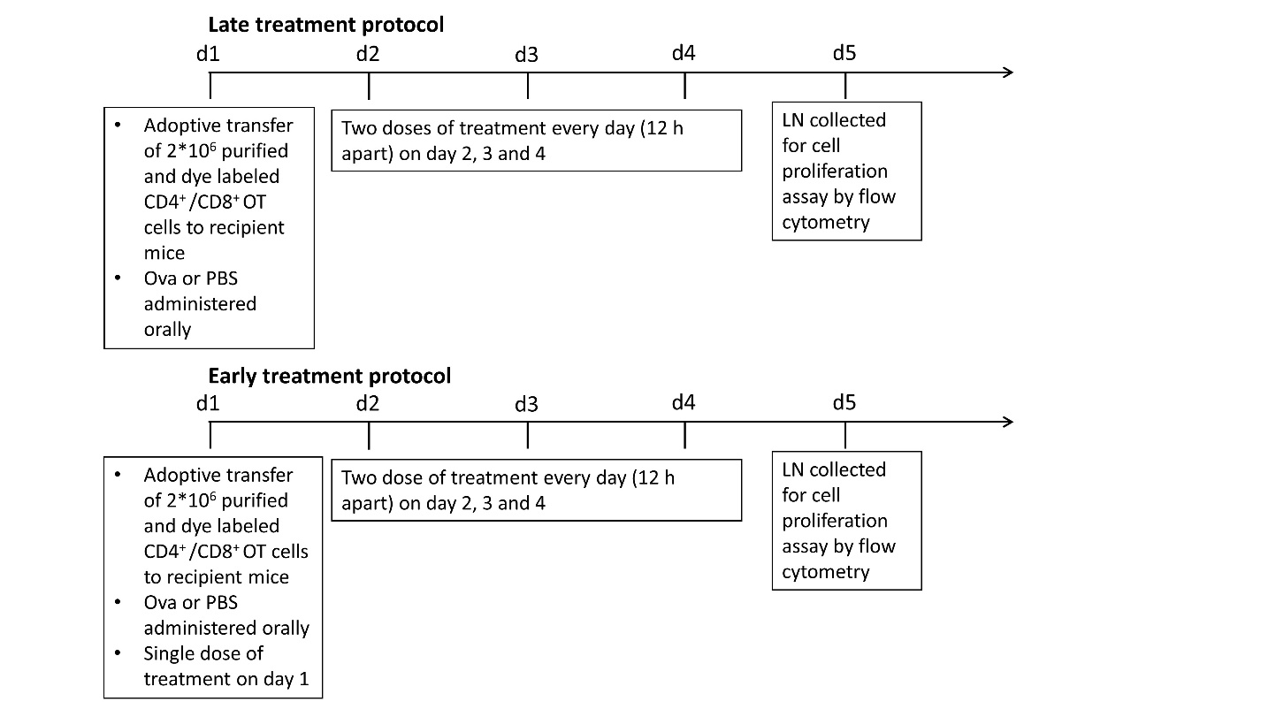

**Figure S-1**: Summary of the experimental design of the immunosuppression experiments using the oral OVA challenge model. On day 1, lymph nodes (LN) from the donor transgenic mice (OT-I and OT-II) were collected, the T cells were purified (CD4+ from OT-II and CD8+ from OT-I transgenic mice) and labelled with the dye CellTraceTM violet (CTV). Recipient mice were divided into 2 groups: OVA treated group where mice were orally administered 50 mg OVA in 0.2 ml PBS for each mouse or a phosphate buffer saline (PBS) treated group where mice were orally administered 0.2 ml PBS for each mouse. Both groups were then administered the labelled OT cells (2 x 106 per mouse) by injection into the tail vein. Thereafter the OVA treated group was further divided into 4 treatment groups: OVA, OVA+MPA, OVA+MPA-TG, and OVA+lipid vehicle. These received no further treatment, MPA, MPA-TG and blank lipid formulation (vehicle only) respectively, twice daily for the following 3 days (Days 2, 3 and 4) in the late treatment protocol. The PBS and OVA treated mice were not administered a treatment from days 2-4 and represented negative and positive control groups, respectively. For the early treatment protocol, the experimental design was altered slightly and drug treatments were initiated on day 1 immediately after injection of cells and continued for the following 3 days. On day 5, all mice were euthanized and the mesenteric lymph nodes (MLN) and peripheral lymph nodes (PLN), collected separately to determine the proliferation of OT cells by flow cytometry.

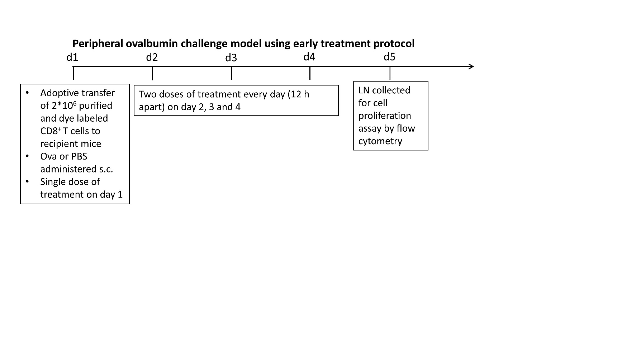**Figure S-2:** Experimental design of the peripheral OVA challenge model. On day 1, lymph nodes (LN) from the donor transgenic mice (OT 1) were collected, CD8+ T cells were purified and labelled with the dye CellTraceTM violet (CTV). Recipient mice were divided into 2 groups: an OVA treated group where mice were administered 10 µl of the emulsion of OVA in incomplete Freund’s adjuvant (IFA) (10 µg/µl) subcutaneously (sc) into the hind leg or a phosphate buffer saline (PBS) treated group where mice were administered an equal volume of PBS into the hind leg. Both groups were then administered the labelled OT cells (2 x 106 per mouse) by injection into the tail vein. Thereafter the OVA treated group was further divided into 4 treatment groups: OVA, OVA+MPA, OVA+MPA-TG, and OVA+lipid vehicle. These received no further treatment, MPA, MPA-TG and blank lipid formulation respectively and the early treatment protocol was followed. On day 5, all mice were euthanized and the mesenteric lymph nodes (MLN) and peripheral lymph nodes (PLN) were collected separately to determine the proliferation of OT cells by flow cytometry.

**4. Plasma pharmacokinetic summary data**

**Table S-2:** Plasma pharmacokinetic parameters for MPA, including AUC(0-6h), Cmax (mean ± SEM) and Tmax (median and range).

|  |  |  |  |  |  |  |
| --- | --- | --- | --- | --- | --- | --- |
| Dosing regime | **MPA** | | | **MPA-TG** | | |
| AUC(0-6h) (µg/ml·h) | Cmax (µg/ml) | Tmax(h) | AUC(0-6h) (µg/ml·h) | Cmax (µg/ml) | Tmax(h) |
| **Single dose** | 43.4 ± 1.59 | 15.2 ± 1.29 | 0.5 | 54.0 ± 7.98 | 25.4 ± 7.20 | 0.5 |
| **Multiple dose** | 67.3 ± 5.63 | 27.0 ± 3.86 | 0.4  (0.25 -0.5) | 72.3 ± 10.90 | 33.3 ± 7.65 | 1.3  (0.25 – 2) |

**5. MPA exposure in LN summary data**

**Table S-3:** AUC(0-6h) of MPA in the lymph nodes after single- and multiple-dose administration of MPA and MPA-TG. Data is presented as mean (n=3-4) ± SEM.

|  |  |  |  |  |
| --- | --- | --- | --- | --- |
|  | MLN | | PLN | |
| PK study | MPA | MPA-TG | MPA | MPA-TG |
| Single dose AUC(0-6h) (µg/g·h) | 9.31 ± 1.2 | 163.5 ± 64.7 **\*** | 2.69 ± 0.4 | 7.40 ± 1.7 |
| Multiple dose AUC(0-6h) (µg/g·h) | 27.8 ± 4.4 | 148.4 ± 13.5 **\*** | 12.8 ± 0.5 | 16.0 ± 2.7 |

**\*** indicates a statistically significant difference in comparison to MPA in MLN group (p<0.05)

**6. Additional LN immunofluorescence imaging at 1 h post dose**

Female C57BL/6 mice were orally gavaged with 0.1 mg of BDP-TG (a fluorescent model prodrug) in a lipid-based formulation as detailed in Table 1 in order to visualise the location of the prodrug in the LN. Mice were sacrificed at 1h post-dose, and their mesenteric (upper MLN) and the peripheral (inguinal) LNs were obtained. To compare the distribution in the peripheral LN, the inguinal LN was used as a representative peripheral LN. Since Bodipy is a lipophilic compound and might have some lymphatic transport inherently (ie in the non-prodrug form) a group of mice were also orally gavaged with parent Bodipy (BDP acid). Each mouse in the BDP acid group received 0.04 mg of BDP acid (molar equivalent of 0.1 mg BDP-2-TG) and upper MLN were collected at 1 h to assess whether there was any detectable Bodipy in the MLN (without using the prodrug approach).

The LNs collected from different groups (n=3) were fixed in 4 % paraformaldehyde in PBS solution for 12 h at 4 °C, washed with PBS, dehydrated in 30% sucrose and embedded in Tissue Tek® O.C.T. medium (Proscitech, QLD, AU) by snap-freezing on dry ice. The cryomoulds were stored at -80 °C until used. Sections (14 µm) were cut using a Leica CM1850 cryostat at -20 °C and thawed onto SuperfrostTM slides and preserved at -80 °C until staining. The slide mounted sections were thawed at room temperature for 20 minutes and rehydrated with wash buffer (PBS + 0.3% Triton X) for 10 minutes prior to staining procedures. The sections were blocked at room temperature using blocking buffer (5 % goat serum in wash buffer) for 1 h and then stained with primary antibodies (0.5 mg/ml, 1 in 200 dilution): rat anti-F4/80 (Biolegend), rabbit anti-LYVE-1 antibody (Fitzgerald, NY, USA) for 2 h at room temperature in a dark closed container. Sections were then washed 3 times for 15 min each time and then incubated for 1 h with the secondary antibodies (2 mg/ml,1 in 500 dilution) against the host species of the primary antibody: goat anti-rabbit Alexa Fluoro 488 antibody, goat anti-rat Alexa Fluoro 647 antibody (Life Technologies, CA, USA). For the identification of the nuclei, Hoechst 33342 (Life Technologies, CA, USA), 1 in 1000 dilution was used during the secondary antibody incubation step. Tissues were finally washed in PBS three times every 10 minutes and mounted using ProLong™ Gold Antifade Mountant (Thermo Fischer Scientific, VIC, AU). For identification of subcapsular macrophages (SCM), a direct immunofluorescence approach was used, wherein the fluorochrome was directly conjugated to a primary antibody against CD169 (CD169 (Siglec-1) Monoclonal Antibody (SER-4), eFluor 660, eBioscienceTM,ThermoFischer, VIC, AU) and used at 1: 50 dilution. The CD169 marker is positive for both SCM and medullary sinus macrophages (MSM) while F4/80 marker is positive only for MSM. The sections were then imaged under a confocal microscope (Leica SP8) using a 20x Plan Apo CS2 NA0.75 objective controlled by LAS AF (version 3.5) image acquisition and processing software (Leica, Wetzlar, Germany). Excitation/emission wavelengths were as follows: 405/490 nm for Alexa 405 (excited by UV light), 495/550 nm for Alexa 488 (excited by 488 laser), 550/600 nm for Alexa 568 (excited by 568 laser) and 600/700 nm for Alexa 647 (excited by 633 laser).

Confocal imaging was performed to visualise the distribution of Bodipy in different cell types in the LN. The identification markers used for lymphatic endothelial cells, subcapsular macrophages (SCM) and medullary macrophages (MM) were Lyve1, CD169 and F4/80 respectively as described in Table S-4.

**Table S-4:** Details of antibodies used to identify cell specific markers and nuclei during immunofluorescence of LN sections.

|  |  |  |
| --- | --- | --- |
| **Cell type** | **Marker used** | **Primary and secondary antibodies** |
| Subcapsular macrophages (SCM) | CD169 | CD169 (Siglec-1) monoclonal antibody (SER-4), eFluor 660 |
| Medullary macrophages (MM) | F4/80 | Rat anti-F4/80 followed by goat anti-rat Alexa Fluoro 647 antibody |
| Nuclei | - | Hoechst 33342 staining |
| Lymphatic endothelial cells (LEC) | Lyve 1 | Rabbit anti-Lyve1 followed by goat anti-rabbit Alexa Fluoro 488 |

The MM were positive for both CD169 and F4/80 while SCM were positive only for CD169 [1].

At 1 hr after oral administration of BDP-TG, within the MLN, the majority of the Bodipy was present in the SCS region and medulla. At this timepoint, there was high co-localisation of Bodipy with lymphatic endothelial cells (LEC), SCM and MM (Figure S-3). In contrast in the PLN, only minor traces of Bodipy were seen Figure S-4, in agreement with the findings for MPA-TG that the TG mimetic prodrug approach leads to high concentration in the MLN but only minimal exposure of drug in the PLN. After administration of Bodipy alone, levels in the MLN were essentially undetectable (Figure S-4).

.

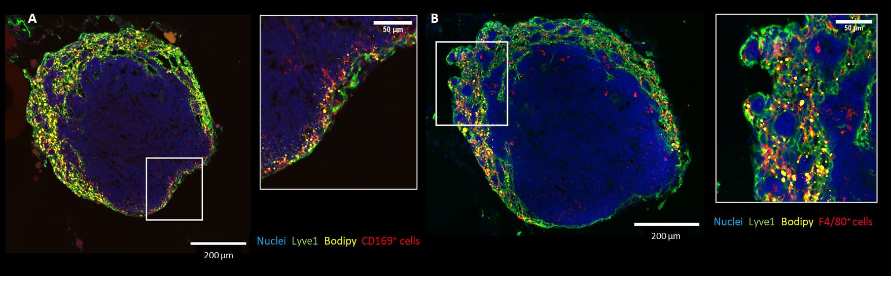

**Figure S-3:** Representative images showing distribution of Bodipy within the MLN at 1 hr post dose and co-staining of **Panel A**) CD 169 positive cells; Panel; **Panel B)** F4/80 positive cells after oral administration of BDP-TG in a lipid based formulation. Scale bars represent 200 µm for the whole node image and 50 µm for the magnified sections on the right.

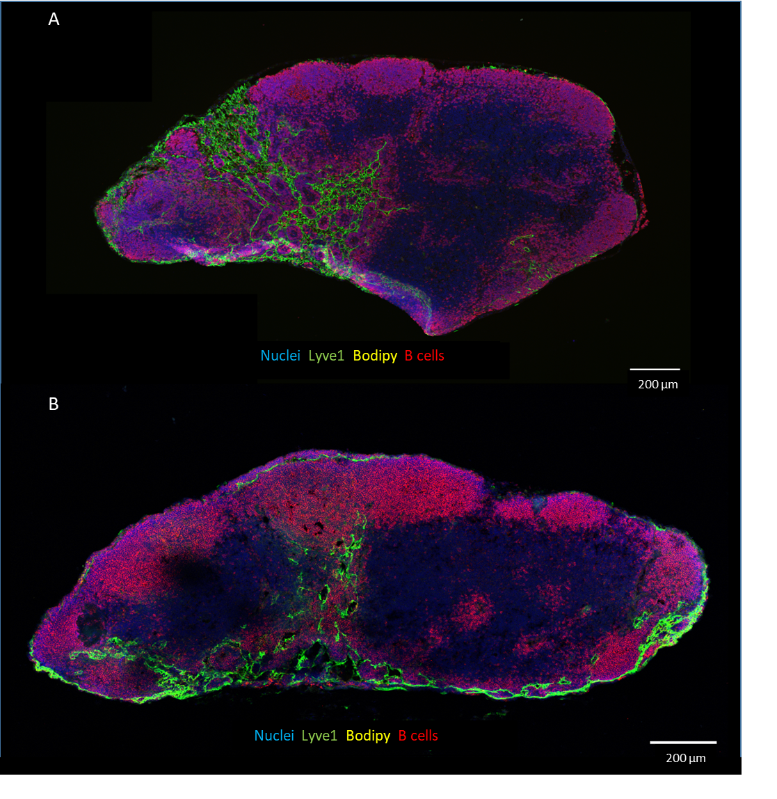**Figure S-4:** **A)** Representative image showing distribution of Bodipy within the MLN at 1h after oral administration of parent Bodipy in lipid based formulation. **B)** Representative image showing distribution of Bodipy within the PLN at 1h after oral administration of BDP-TG in lipid-based formulation. Scale bars represent 200 µm.

**7. Analytical methods for MPA in lymph, plasma and LN**

HPLC-MS/MS analysis of lymph, plasma and lymph nodes

A Shimadzu LC-MS/MS 8030 or 8050 system (Shimadzu Scientific Instruments, Kyoto, Japan) was used for analysis. It consisted of a CBM-20A system controller, a DGU-20A5 solvent degasser, two LC-30AD pumps, a SIL-30AC MP auto sampler, a CT-20A column oven (held at 40 °C), and a triple quadrupole mass spectrometer with an electrospray ionization interface (ESI). The desolvation line (DL) and the heat block were maintained at 230 °C and 300 °C, respectively. The interface and detector voltages were 4.5 kV and 2.0 kV, respectively. The nebulizing gas flow rate and drying gas flow rate were 1.5 L/min and 15 L/min, respectively. For each injection, 10 µl of sample was injected onto the HPLC column. The tray temperature in the auto sampler was maintained at 15 °C. The mobile phase, flow rate, HPLC column, HPLC-MS/MS instrument, retention time and m/z ion (+) used for the detection of various analytes in different matrixes are detailed in Table S-5.

**Table S-5**: HPLC-MS/MS conditions for the analysis of MPA.

|  |  |
| --- | --- |
| **Analyte** | MPA |
| **Matrix** | Lymph/ Plasma/lymph Node |
| **Mobile phase** | 82:18 (v/v) ACN : water with 2 mM ammonium formate, 0.1% (v/v) formic acid |
| **Flow rate** | 0.4 ml/min, isocratic |
| **HPLC column** | Luna C8 100A column (5 µm particle size, 150 mm × 4.60 mm i.d. Phenomenex, CA, USA) |
| **Instrument** | Shimadzu LC-MS/MS 8030 or 8050 system |
| **Retention time (min)** | 4.4 min for MPA  4.7 min for ketoprofen (internal standard) |
| **m/z ion (+) peak used for detection** | MPA: 320.95 🡪 302.95  Ketoprofen: 254.95 |

**Sample preparation for high performance liquid chromatography - tandem mass spectrometry (HPLC-MS/MS) analysis**

**Lymph sample preparation to determine total MPA**

Total MPA in lymph in the prodrug-dosed group was assayed using a hydrolysis method for the glyceride derivatives in the lymph as described previously (12). This method was adopted because the MPA-TG prodrug is first hydrolysed to a monoglyceride form in the GIT lumen and, after absorption into the enterocytes, is resynthesised with different fatty acids (depending on the endogenous fatty acids in the enterocyte and exogenous fatty acids from the formulation) to yield a variety of glyceride derivatives of MPA. These cannot be readily quantified individually. Samples were therefore hydrolysed to release MPA and then MPA was quantified. Briefly, the method involved hydrolysis of glyceride derivatives of MPA in lymph via addition of 140 µl 0.5 M NaOH in 1:1 (v/v) ethanol: water to 20 µl of lymph and heating at 80 °C for 5 min. Subsequently, 70 µl of 1 M HCl was added to each sample to stop the hydrolysis. After vortexeing for 0.5 min, a 70 µl aliquot of the sample was diluted with 930 µl mobile phase (see supplementary Table S-5), vortexed for a further 1 min, centrifuged at 4500 g for 5 min, and 150 µl of the supernatant analysed for MPA by HPLC-MS/MS, as described below. Ketoprofen (100 µg/ml) was used as an internal standard, and 5 µl was added to 20 µl lymph aliquots before the hydrolysis step was initiated.

**Plasma sample preparation to determine total MPA**

To quantify the concentration of MPA in plasma, plasma proteins were first precipitated using a saturated ammonium sulphate solution. Briefly, 5 µl of the internal standard solution (100 µg/ml ketoprofen) was added to 20 µl plasma samples, which were then vortexed. Plasma proteins were precipitated by addition of 170 µl saturated ammonium sulphate solution and the samples were vortexed again for 30 s. Extraction of MPA was facilitated by addition of 800 µl acetonitrile (ACN) containing 0.1 % w/v formic acid, samples were vortexed again for 30 s and centrifuged at 4248 g for 8 min at 25 °C. Then, 150 µl of supernatant was collected and analysed for MPA concentration by HPLC-MS/MS, as described in supplementary Table S-5.

**Lymph node sample preparation to determine free MPA**

LN was placed into pre-weighed polypropylene microtubes (BRAND® PP microtubes). A scoop of garnet beads (~10 mg) and 75 µl water was added before homogenization using a FASTPrep24-5G (MP Biomedicals, CA USA). The samples were subjected to thee 45 s cycles of homogenisation at a speed of 6–8 m/s. This was followed by addition of 300 µl of ACN containing 0.1 % w/v formic acid. The tubes were then centrifuged at 4500 g for 5 min and the supernatant assayed for MPA using HPLC-MS/MS.

**8. Calculations**

Lymphatic transport data

The lymph concentrations of MPA (after hydrolysis of total MPA glycerides) obtained by HPLC-MS analysis were converted to masses of total MPA transported into the lymph by multiplying the measured concentrations by the volume of lymph collected per h (which was assessed gravimetrically). This was converted into a percentage of the dose transported into lymph per h by dividing the mass of MPA transported into lymph by the dose of MPA or the quantity of MPA in the MPA-TG prodrug administered. The cumulative percentage of the dose transported into lymph was then quantified as a function of time. To obtain the dose normalised mass of MPA transported into lymph when given as parent drug or prodrug, the percentage of the dose was multiplied by the actual amount of MPA dosed for that group, which was 368 µg for MPA-TG and 250 µg for MPA treated animals.

**Plasma pharmacokinetic analysis**

The concentrations of MPA in plasma were plotted as a function of time. The pharmacokinetic parameters of maximum plasma concentration (Cmax) and time to maximum concentration (Tmax) were taken directly from the plasma concentration-time curves. The area under the curve from 0 to 6 h (AUC0-6h) was calculated using the linear trapezoidal method in accordance with Bailers approach [2]. The standard error for the AUC was calculated using the Bailer’s method as a sparse sampling approach was used for collecting plasma samples.

**Lymph node exposure data**

The mass of MPA contained in a known mass of lymph nodes (typically 20 mg) was calculated by comparison to a series of spiked standards made up in same mass of blank lymph nodes. MPA concentrations in sample lymph node homogenate were quantified by comparison with MPA concentrations in spiked lymph node homogenates. The total mass of MPA per sample was then calculated by multiplying the measured concentration by the known volume of node homogenate. The mass of MPA per mg of node was subsequently calculated by dividing the mass of MPA per sample by the mass of lymph node in the sample tube. The homogenisation method did not lead to release or breakdown of MPA from MPA-TG prodrug.

Cumulative % of cells in each generation in the oral and peripheral OVA challenge model

In the CTV histograms the parent or reference generation was denoted Generation 0 (G0) and Generations Gi (i=1 to 8) were the daughter generations produced as a result of cell division from the parent G0 population. The peaks were gated and labelled as G0, G1, G2 etc. moving from the right side to the left side of the histogram plot The proportion (%) of the cells in each peak relative to the total was calculated based on the ratio of the number of cells present within each peak divided by the total number of cells. The cumulative percentage of cells present from G0 up to each generation was then plotted as a function of generation. Thus, for undivided cells 100% of the cells were in G0, whereas in cells where significant cell division had taken place the % cells in the early generations (G0, 1, 2, 3 etc.) was reduced and the proportion in the later generations (G4, 5, 6, 7, 8) increased. Effective immunosuppression limits cell replication and shifts the proportion of cells in each generation back towards G0. Thus, a decrease in the % cells in later generations signifies immunosuppression.

**9. Immunomodulation data for OT II cells using the early treatment protocol in oral ovalbumin challenge model**

The oral ovalbumin challenge for OT II T cells experiment was also conducted using the ‘early’ treatment protocol, where an additional dose was given on day 1. In this experiment, the additional early dose had no impact on the data obtained across all treatment groups except for the lipid vehicle group, where surprisingly, some inhibition of cell division was apparent. The data suggest that the lipid in the formulation may have an impact on immune-stimulation, but only when given very soon after the OVA challenge (since this was not observed in the late treatment protocol).

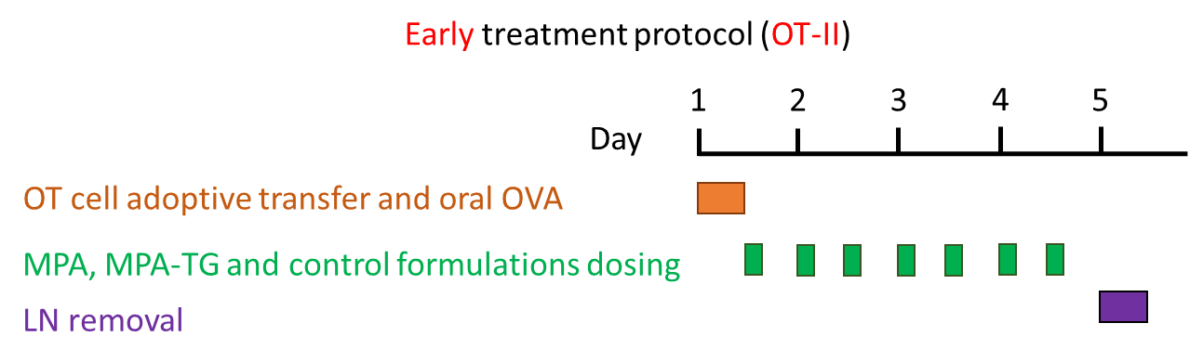

|  |  |
| --- | --- |
| A | B |

**Figure S-5:** Panel A shows the response in MLN and Panel B shows the response in PLN for the five treatment groups using the early treatment protocol. Statistical analysis was carried out to compare the effect of MPA and MPA-TG versus OVA at each generation by two-way ANOVA, followed by Bonferroni’s test. Data (mean ± SEM) are representative of two independent experiments with 3–4 mice per group except for the PBS group where n=2 mice were used in each experiment. * indicates p value < 0.05 vs OVA (positive control group).

**10. Immunomodulation data for OT I cells using the late treatment protocol in oral ovalbumin challenge model**

As shown below, using the late treatment protocol with OT I cells was unable to show any suppression of T cell replication with any of the treatments. As such the early treatment protocol was employed for the main studies.

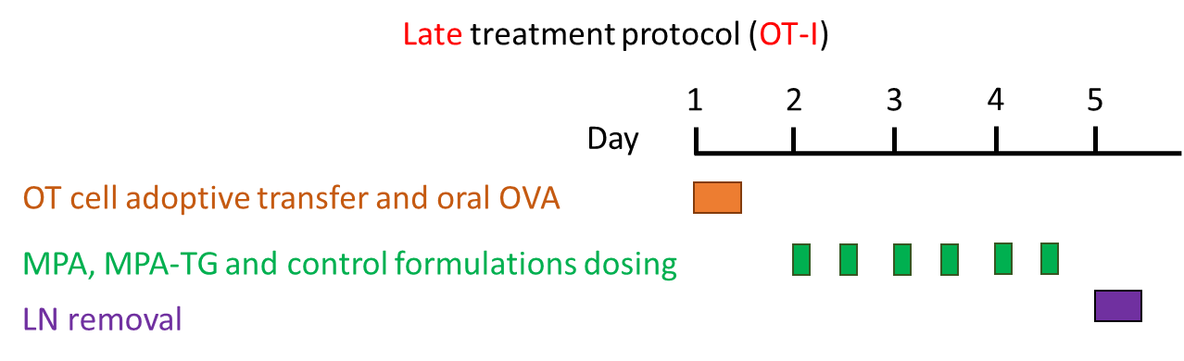

|  |  |
| --- | --- |
| A | B |

**Figure S-6:** Panel A shows the response in MLN and Panel B shows the response in PLN for the five treatment groups using the late treatment protocol**.** Statistical analysis was carried out to compare the effect of MPA and MPA-TG versus OVA at each generation by two-way ANOVA, followed by Bonferroni’s test. Data (mean) are representative of experiment with n=2 to 3 mice per group.

**11. Immunomodulation data in the Peyers’ patches (PP) for OT I cells using early treatment protocol in oral ovalbumin challenge model.**

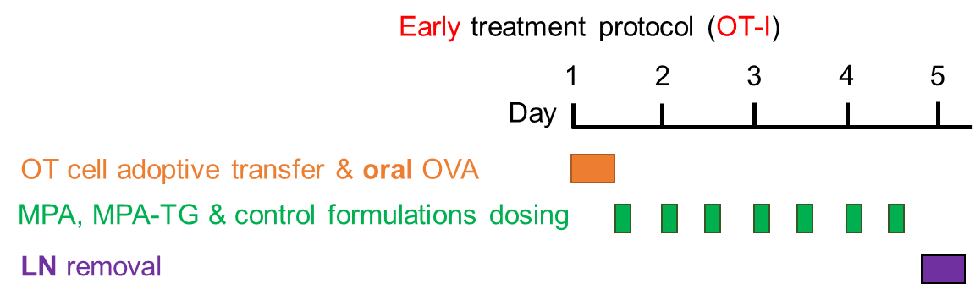



**Figure S-7:** T cell proliferation response in PP for the five treatment groups using the early treatment protocol using OT-I mice**.** Statistical analysis was carried out to compare the effect of MPA and MPA-TG versus OVA at each generation by two-way ANOVA, followed by Bonferroni’s test. Data (mean ± SEM) are representative of experiment with n=3 mice per group. For PBS group, n=2 mice were used and hence data is represented as mean ± range in the graph. * indicates p value < 0.05 vs OVA (positive control group).

**12. Bodipy TG lymph transport data in rats**

The lymphatic transport of Bodipy-TG (BDP_TG) was assessed in rats to confirm integration into the triglyceride transport pathway, and therefore behaviour similar to MPA-TG in terms of transport via the mesenteric lymphatics. For this study, anesthetized mesenteric lymph duct cannulated male Sprague Dawley rats were used. BDP-TG in a lipid based formulation was administered as an intraduodenal infusion at a rate of 2.8 mL/h over 2 h to the rats and lymph was collected up to 6h. The formulation was made using a similar method to that described in the main text for LBF of MPA-TG although volumes were larger since the study was conducted in rats. Thus BDP-TG (500 µg) was solubilised in Tween 80 (25 mg) and oleic acid (40 mg); mixed with PBS, pH 7.4 (5.6 mL) and emulsified by ultrasonication with a Misonix XL 2020 ultrasonic processor (Misonix, Farmingdale, NY, USA) using a 3.2-mm microprobe tip at an amplitude of 240 μm and a frequency of 20 kHz for 2 min at room temperature. Lymph samples were diluted with 1 mL of acetonitrile, centrifuged at 4500 g and fluorescence in the supernatant quantified. The fluorescence emitted in the samples was measured using a plate reader (Ensight, Perkin Elmer, MA, USA) at 553-568 nm wavelengths and calibrated against Bodipy-TG standards. The results show that lymphatic transport of BDP-TG was 28.5 ± 5.5% (mean ± SD) of the dose administered. After administration of parent bodipy, the levels of fluorescence in the mesenteric lymph were below the limit of detection providing further confirmation that the TG-mimetic prodrug approach is able to significantly enhance lymphatic transport.



**Figure S-8:** Cumulative lymphatic transport of Bodipy-TG, as percentage of the dose of Bodipy-TG, over 6 h after intraduodenal administration of Bodipy-TG at 500 µg dose in a LBF. Data are presented as mean ± SD for n = 3 rats.

References:

1. Detienne, S., I. Welsby, C. Collignon, et al., *Central Role of CD169(+) Lymph Node Resident Macrophages in the Adjuvanticity of the QS-21 Component of AS01.* Sci Rep, 2016. **6**: p. 39475.

2. Bailer, A.J., *Testing for the equality of area under the curves when using destructive measurement techniques.* Journal of Pharmacokinetics and Biopharmaceutics, 1988. **16**(3): p. 303-309.