Role of LFA-1 integrin in the control
of a lymphocytic choriomeningitis virus (LCMV) infection

Supplementary Material

SUPPLEMENTAL FIGURES
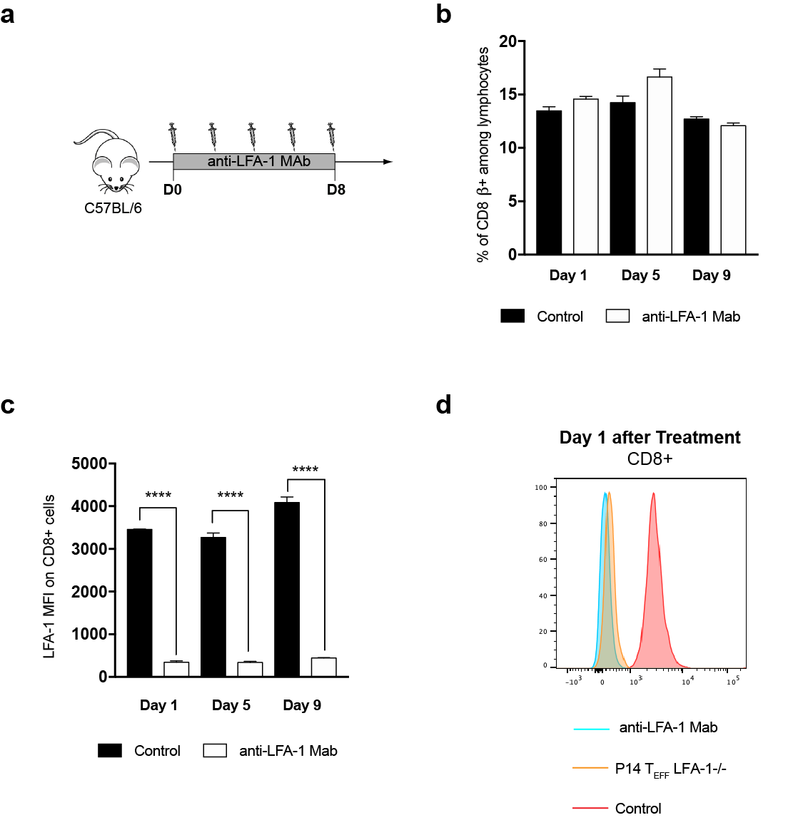
Figure S1. Impact of anti-LFA1 Mab treatment in non-infected mice.
(a) C57Bl/6 mice were treated with 200μg anti-LFA-1 Mab (BioXcell, clone M17/4) every 2 days for 8 consecutive days. During anti-LFA1 Mab treatment blood CD8+ T cells were isolated and their numbers (b) and expression levels of LFA-1 were quantified by flow cytometry (c,d). In order to detect the amount of free LFA-1 molecules in CD8 T cell isolated from anti-LFA1 treated mice we performed an antibody staining with the same clone (M17/4) that was used for treatment. As a control we used day 9 LFA1-/- P14 T_{EFF} isolated from LCMV-CL13 mice.

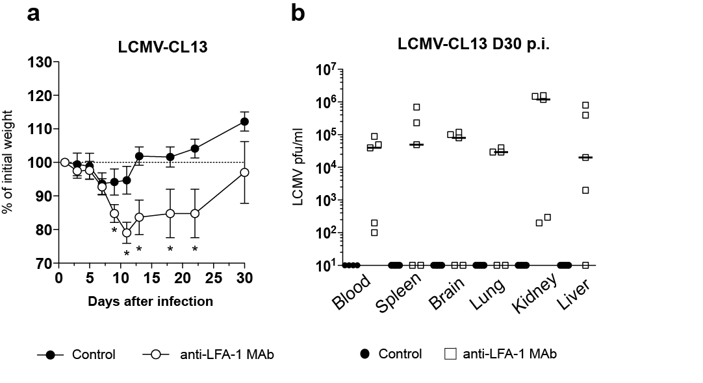
Figure S2. Impact of anti-LFA-1 Mab antibody treatment on disease and control of LCMV-CL13 viremia. (a) Monitoring of weight loss during LCMV-CL13 infection. (b) LCMV viral titers were determined by plaque assay in in several organs at day 30 post-infection for LCMV-CL13 infected mice. Detection limit 100pfu.
* p<0.05, ** p<0.001, *** p<0.0001. Error bars represent mean±SEM. Three independent experiments including 3 mice per group were performed with similar results.
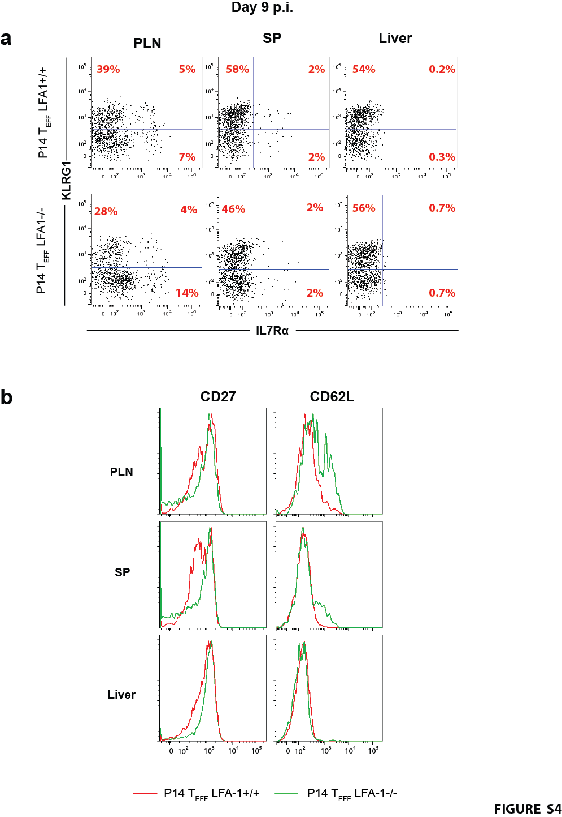

Figure S3. Impact of LFA-1 deficiency in T_{EFF} differentiation after LCMV-CL13 infection.
(a,b) Surface expression of KLRG1, IL7Rα, CD27 and CD62L was evaluated in the WT and LFA1^{-/-} P14 T_{EFF} from different organs at the day 9 p.i. with (5x10⁴pfu) LCMV-CL13.
Two independent experiments including 3 mice per group were performed with similar results.
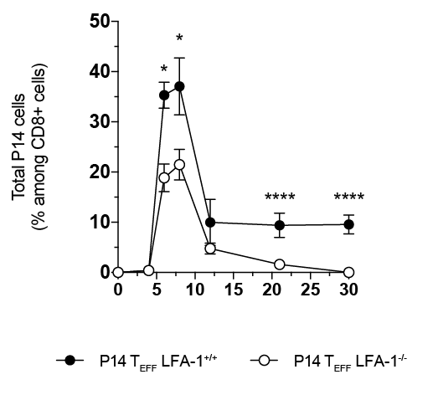

Figure S4. Impact of LFA-1 on CD8 T cells burst size after LCMV-CL13 infection.
A small number (10,000 cells) of naïve LFA-1^{+/+} CD45.1⁺ and LFA-1^{-/-} CD45.2⁺ P14 T_{N} cells were enriched by magnetic negative selection (>95% purity) and transferred into the separate WT CD45.2⁺ recipient, thus generating P14 chimeric mice. (c) 24 hours later, recipient mice were i.v. challenged with LCMV-CL13 (5x10⁴ pfu) that were able to clear infection with kinetics similar to non-chimeric mice. T_{EFF} burst size was quantified overtime in the blood of LCMV-CL13 infected mice by flow cytometry.

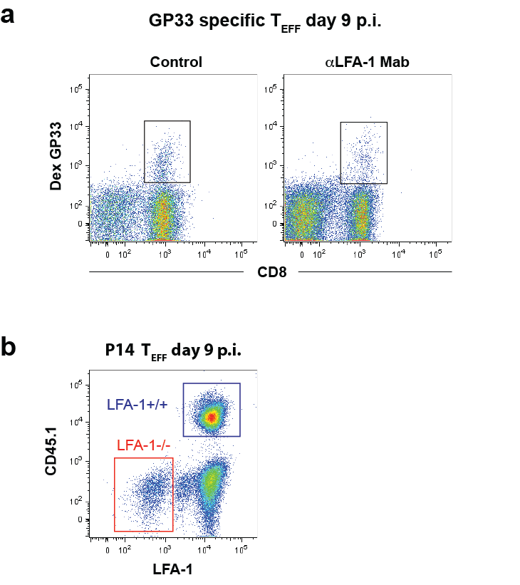
Figure S5. Gating strategy for transcriptome analysis. (a) DexGP-33 T_{EFF} were identified based on their surface expression of CD8 and binding to Dextramer GP33. (b) P14 T_{EFF} were identified based on their surface expression of LFA-1 and CD45.1 after gating on CD8+ lymphocytes.

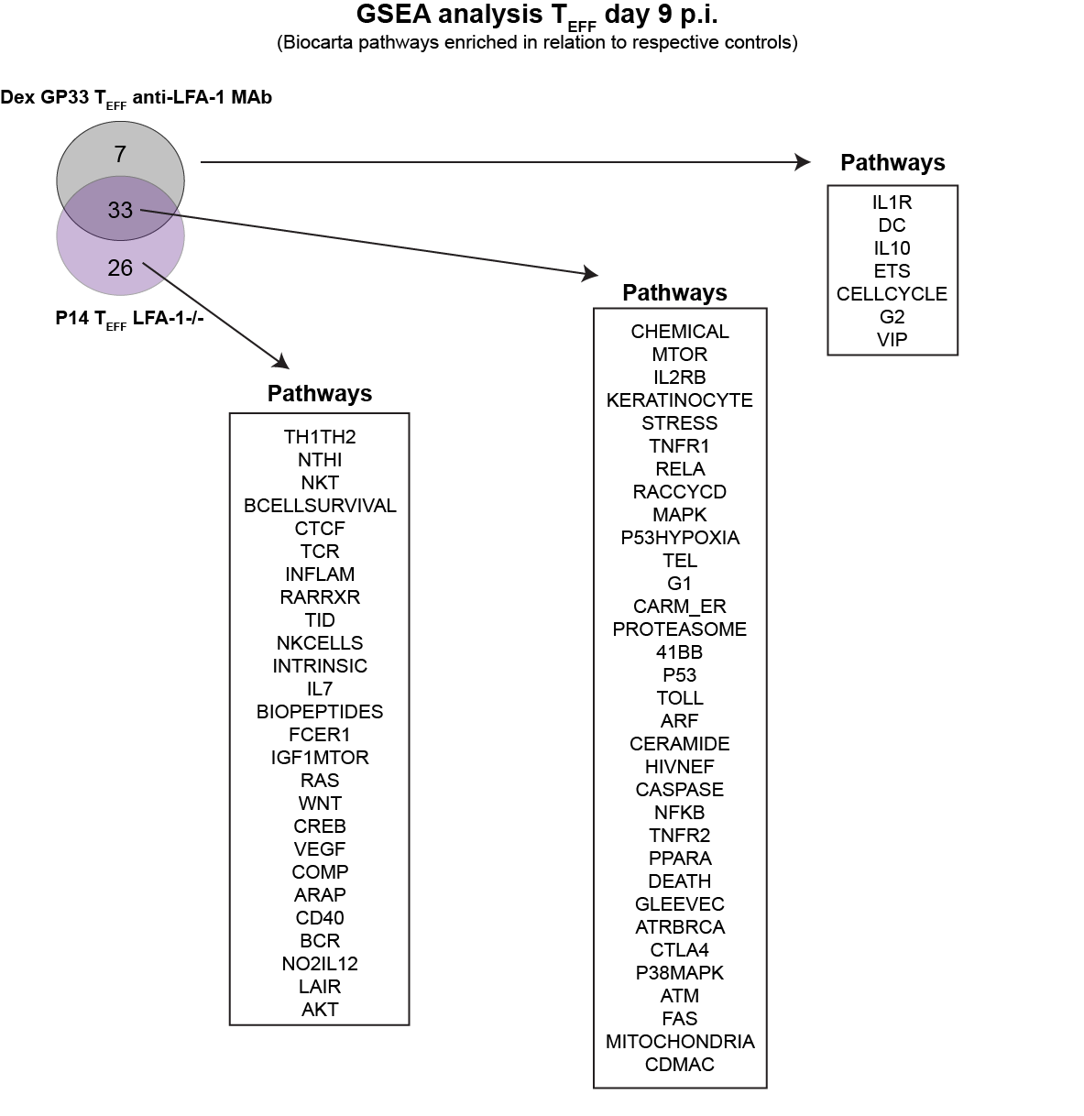

Figure S6. GSEA analysis of P14 and DexGP-33 T_{EFF} generated during LCMV-CL13 infection. (a) Overlap in the pathways identified by GSEA to be enriched in LFA1^{-/-} P14 T_{EFF} and DexGP-33 T_{EFF} from anti-LFA-1 Mab treated mice at day 9 p.i. when compared to LFA1^{+/+} P14 T_{EFF} and DexGP-33 T_{EFF} from control infected mice, respectively.

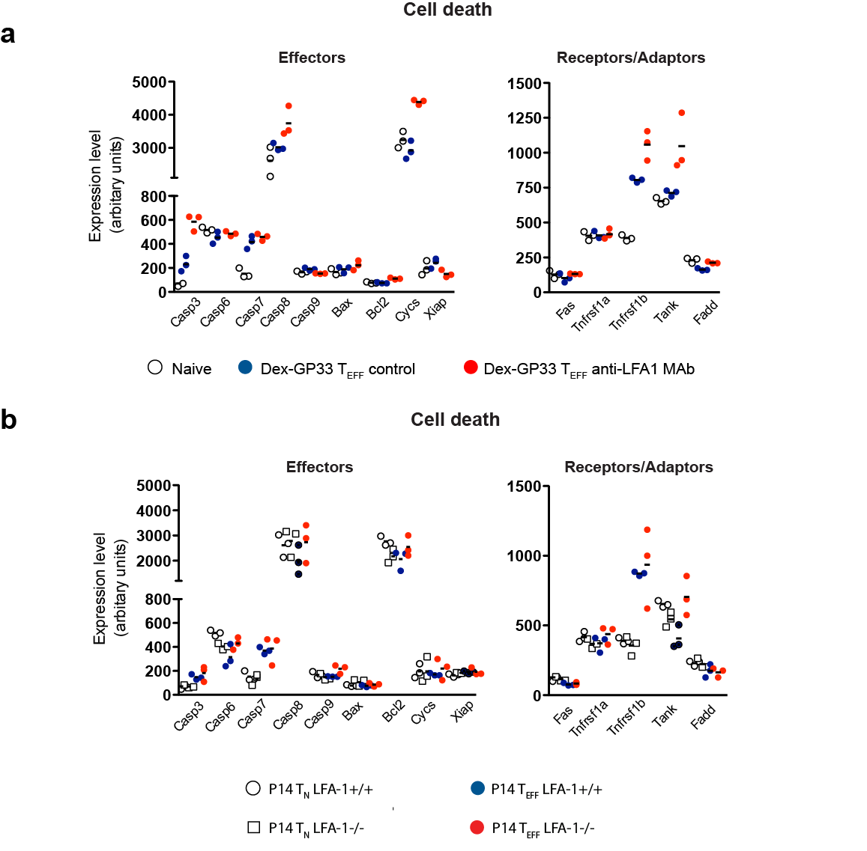

Figure S7. Naïve P14, P14 and DexGP-33 T_{EFF} expression of a set of genes involved in cell death.
(a) Relative expression levels of genes in Dex-GP-33 T_{EFF} from control and anti-LFA-1 Mab treated mice in comparison to P14 LFA1^{+/+} naïve cells. (b) Relative expression levels of genes in LFA1^{+/+} and LFA1^{-/-} P14 T_{EFF} in comparison to LFA1^{+/+} and LFA1^{-/-} P14 naïve cells.

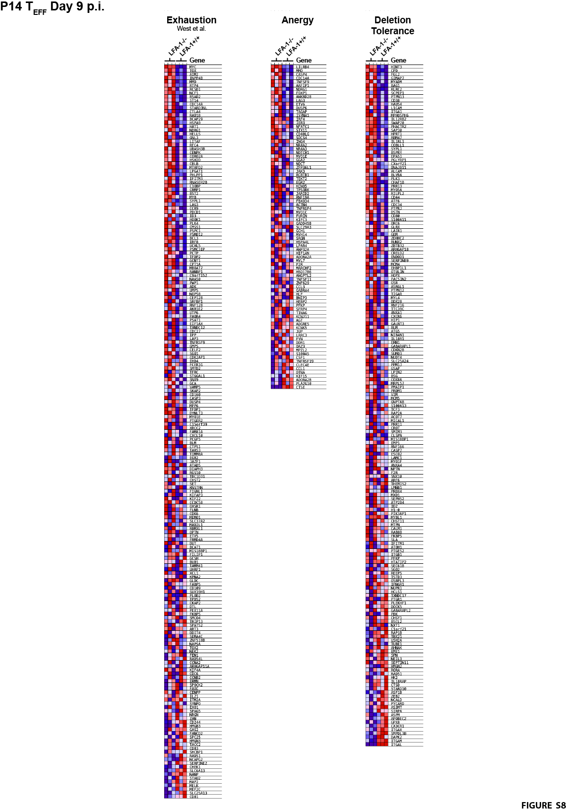
Figure S8. Transcriptional signatures of exhaustion, anergy and deletion tolerance in T_{EFF} in P14 T_{EFF}. Geneset enrichment analysis (GSEA) on T cells exhaustion ⁴¹, anergy ⁴⁰ and deletion tolerance ³⁹signatures from MSigDB v7.1 (Broad institute) was performed on day 9 P14 T_{EFF} from LCMV-CL13 infection mice.

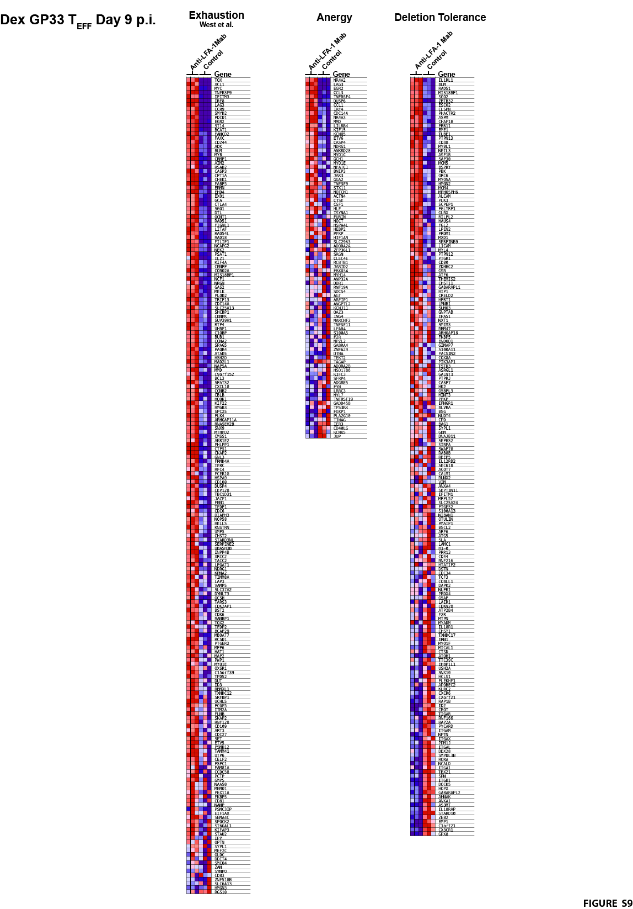
Figure S9. Transcriptional signatures of exhaustion, anergy and deletion tolerance in Dex-GP33 specific. Geneset enrichment analysis (GSEA) on T cells exhaustion ⁴¹, anergy ⁴⁰ and deletion tolerance ³⁹signatures from MSigDB v7.1 (Broad institute) was performed on day 9 Dex-GP33 T_{EFF} from LCLV-CL13 infection mice.
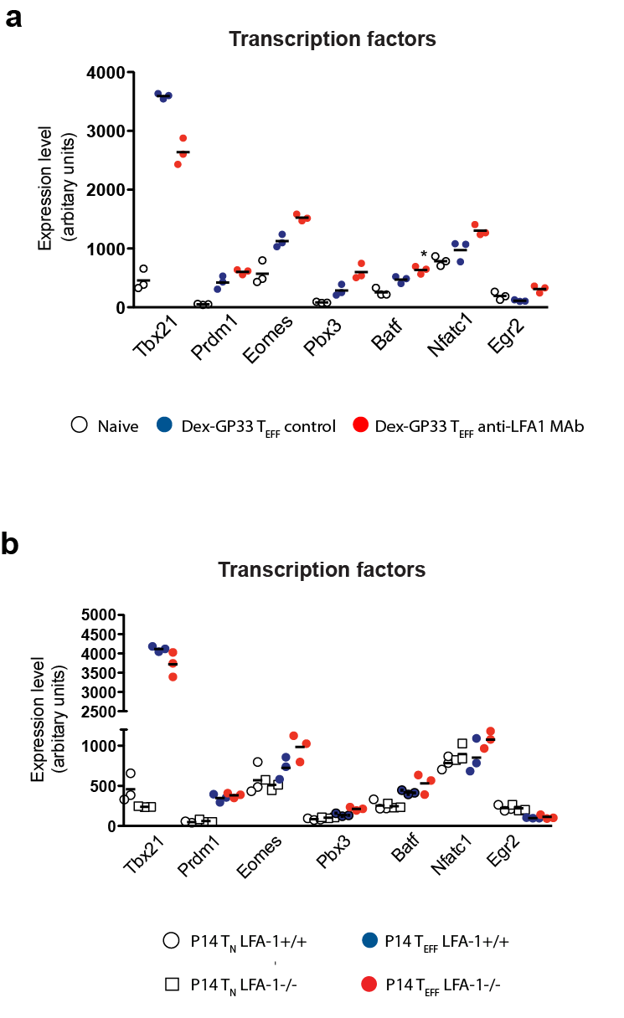
Figure S10. Naïve P14, P14 and DexGP-33 T_{EFF} expression of a set of transcription factor genes involved in CD8 T cell function. (a) Relative expression levels of genes in Dex-GP-33 T_{EFF} from control and anti-LFA-1 Mab treated mice in comparison to P14 LFA1^{+/+} naïve cells. (b) Relative expression levels of genes in LFA1^{+/+} and LFA1^{-/-} P14 T_{EFF} in comparison to LFA1^{+/+} and LFA1^{-/-} P14 naïve cells.

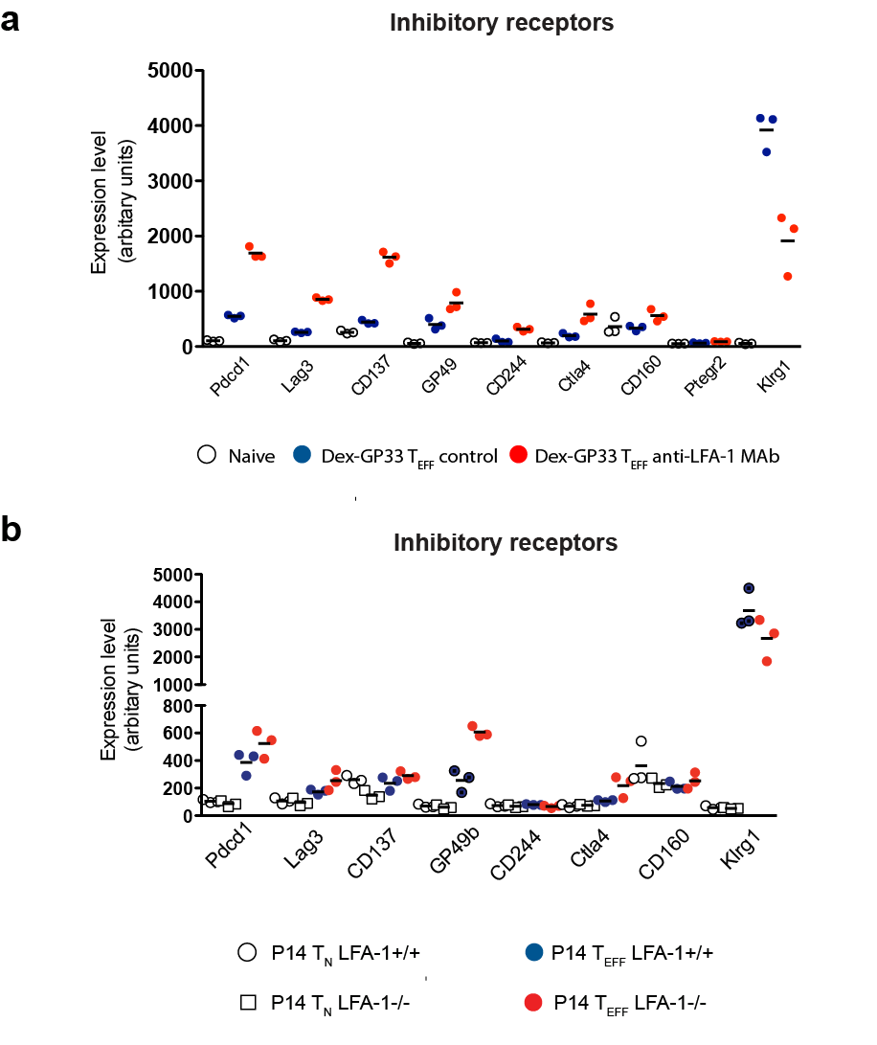
Figure S11. Naïve P14, P14 and DexGP-33 T_{EFF} expression of a set of inhibitory receptor genes involved in CD8 T cell function. (a) Relative expression levels of genes in Dex-GP-33 T_{EFF} from control and anti-LFA-1 Mab treated mice in comparison to P14 LFA1^{+/+} naïve cells. (b) Relative expression levels of genes in LFA1^{+/+} and LFA1^{-/-} P14 T_{EFF} in comparison to LFA1^{+/+} and LFA1^{-/-} P14 naïve cells.

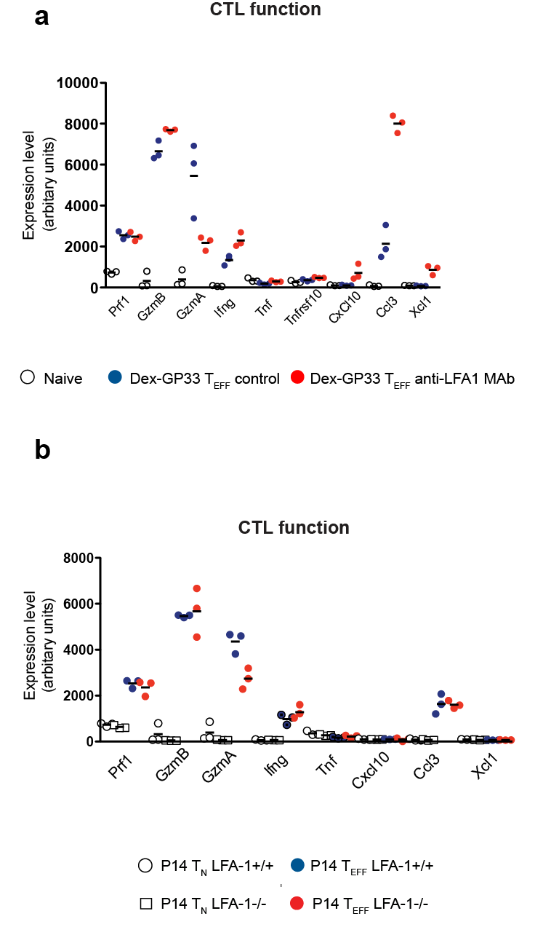
Figure S12. Naïve P14, P14 and DexGP-33 T_{EFF} expression of a set of genes involved in CTL function.
(a) Relative expression levels of genes in Dex-GP-33 T_{EFF} from control and anti-LFA-1 Mab treated mice in comparison to P14 LFA1^{+/+} naïve cells. (b) Relative expression levels of genes in LFA1^{+/+} and LFA1^{-/-} P14 T_{EFF} in comparison to LFA1^{+/+} and LFA1^{-/-} P14 naïve cells.

Table S1. GSEA of BIOCARTA curated gene sets from the Molecular Signatures Database (MSigDB) specifically enriched on CD8 T cells upon anti-LFA-1 ab treatment. GSEA analysis was used to identify cellular pathways significantly enriched in GP33+ specific CD8 T cells from 5x10⁴ pfu LCMV-CL13 infected mice treated with anti-LFA-1 Mab in comparison to those from PBS treated mice. Cut off was established as FDR <20% and p<0.05.

Table S2. GSEA of BIOCARTA curated gene sets from the Molecular Signatures Database (MSigDB) specifically enriched on P14 LFA-1^{-/-} T cells after LCMV infection. GSEA analysis was used to identify cellular pathways significantly enriched in day 9 p.i. LFA-1^{-/-} P14 T_{EFF} in comparison to LFA-1^{+/+} P14 T_{EFF} from 5x10⁴ pfu LCMV-CL13 infected mice. Cut off was established as FDR <20% and p<0.05.

SUPPLEMENTAL REFERENCES
1. von Andrian, U. H. & Mempel, T. R. Homing and cellular traffic in lymph nodes. Nat. Rev. Immunol. 3, 867–878 (2003).
2. Link, A. et al. Fibroblastic reticular cells in lymph nodes regulate the homeostasis of naive T cells. Nat. Immunol. 8, 1255–1265 (2007).
3. von Andrian, U. H. & Mackay, C. R. T-cell function and migration. Two sides of the same coin. N. Engl. J. Med. 343, 1020–1034 (2000).
4. Park, E. J. et al. Distinct roles for LFA-1 affinity regulation during T-cell adhesion, diapedesis, and interstitial migration in lymph nodes. Blood 115, 1572–1581 (2010).
5. Scholer, A., Hugues, S., Boissonnas, A., Fetler, L. & Amigorena, S. Intercellular adhesion molecule-1-dependent stable interactions between T cells and dendritic cells determine CD8+ T cell memory. Immunity 28, 258–270 (2008).
6. Perez, O. D. et al. Leukocyte functional antigen 1 lowers T cell activation thresholds and signaling through cytohesin-1 and Jun-activating binding protein 1. Nat. Immunol. 4, 1083–1092 (2003).
7. Lee, K.-H. et al. The immunological synapse balances T cell receptor signaling and degradation. Science 302, 1218–1222 (2003).
8. Kaufman, Y. Lyt-2 negative and T cell growth factor independent cytotoxic T lymphocyte hybridomas. Advances in Experimental Medicine and Biology 146, 435–446 (1982).
9. Kishimoto, T. K., Hollander, N., Roberts, T. M., Anderson, D. C. & Springer, T. A. Heterogeneous mutations in the beta subunit common to the LFA-1, Mac-1, and p150,95 glycoproteins cause leukocyte adhesion deficiency. Cell 50, 193–202 (1987).
10. Schwab, N. et al. Fatal PML associated with efalizumab therapy: insights into integrin αLβ2 in JC virus control. Neurology 78, 458–467; discussion 465 (2012).
11. Berlin-Rufenach, C. et al. Lymphocyte migration in lymphocyte function-associated antigen (LFA)-1- deficient mice. J. Exp. Med. 189, 1467–1478 (1999).
12. Wohler, J., Bullard, D., Schoeb, T. & Barnum, S. LFA-1 is critical for regulatory T cell homeostasis and function. Mol. Immunol. 46, 2424–2428 (2009).
13. Schmits, R. et al. LFA-1-deficient mice show normal CTL responses to virus but fail to reject immunogenic tumor. J. Exp. Med. 183, 1415–1426 (1996).
14. Ghosh, S., Chackerian, A. A., Parker, C. M., Ballantyne, C. M. & Behar, S. M. The LFA-1 adhesion molecule is required for protective immunity during pulmonary Mycobacterium tuberculosis infection. J. Immunol. 176, 4914–4922 (2006).
15. Prince, J. E. et al. The differential roles of LFA-1 and Mac-1 in host defense against systemic infection with Streptococcus pneumoniae. J. Immunol. 166, 7362–7369 (2001).
16. Miyamoto, M. et al. Neutrophilia in LFA-1-deficient mice confers resistance to listeriosis: possible contribution of granulocyte-colony-stimulating factor and IL-17. J. Immunol. 170, 5228–5234 (2003).
17. Ahmed, R., Salmi, A., Butler, L. D., Chiller, J. M. & Oldstone, M. B. Selection of genetic variants of lymphocytic choriomeningitis virus in spleens of persistently infected mice. Role in suppression of cytotoxic T lymphocyte response and viral persistence. J Exp Med 160, 521–40 (1984).
18. Salvato, M., Borrow, P., Shimomaye, E. & Oldstone, M. B. Molecular basis of viral persistence: a single amino acid change in the glycoprotein of lymphocytic choriomeningitis virus is associated with suppression of the antiviral cytotoxic T-lymphocyte response and establishment of persistence. J. Virol. 65, 1863–1869 (1991).
19. Matloubian, M., Kolhekar, S. R., Somasundaram, T. & Ahmed, R. Molecular determinants of macrophage tropism and viral persistence: importance of single amino acid changes in the polymerase and glycoprotein of lymphocytic choriomeningitis virus. J. Virol. 67, 7340–7349 (1993).
20. Wherry, E. J., Blattman, J. N., Murali-Krishna, K., van der Most, R. & Ahmed, R. Viral persistence alters CD8 T-cell immunodominance and tissue distribution and results in distinct stages of functional impairment. J. Virol. 77, 4911–4927 (2003).
21. Quddus, J., Kaplan, A. & Richardson, B. C. Anti-CD11a prevents deletion of self-reactive T cells in neonatal C57BR mice. Immunology 82, 301–305 (1994).
22. Revilla, C., González, A. L., Conde, C., López-Hoyos, M. & Merino, J. Treatment with anti-LFA-1 alpha monoclonal antibody selectively interferes with the maturation of CD4- 8+ thymocytes. Immunology 90, 550–556 (1997).
23. Peixoto, A. et al. CD8 single-cell gene coexpression reveals three different effector types present at distinct phases of the immune response. J. Exp. Med. 204, 1193–1205 (2007).
24. Wong, P. & Pamer, E. G. Feedback regulation of pathogen-specific T cell priming. Immunity 18, 499–511 (2003).
25. Wherry, E. J. & Kurachi, M. Molecular and cellular insights into T cell exhaustion. Nat. Rev. Immunol. 15, 486–499 (2015).
26. Joshi, N. S. et al. Inflammation directs memory precursor and short-lived effector CD8(+) T cell fates via the graded expression of T-bet transcription factor. Immunity 27, 281–95 (2007).
27. Pircher, H., Bürki, K., Lang, R., Hengartner, H. & Zinkernagel, R. M. Tolerance induction in double specific T-cell receptor transgenic mice varies with antigen. Nature 342, 559–561 (1989).
28. Hamann, A. et al. Evidence for an accessory role of LFA-1 in lymphocyte-high endothelium interaction during homing. J. Immunol. 140, 693–699 (1988).
29. Warnock, R. A., Askari, S., Butcher, E. C. & von Andrian, U. H. Molecular mechanisms of lymphocyte homing to peripheral lymph nodes. J. Exp. Med. 187, 205–216 (1998).
30. Wirth, T. C., Pham, N.-L. L., Harty, J. T. & Badovinac, V. P. High initial frequency of TCR-transgenic CD8 T cells alters inflammation and pathogen clearance without affecting memory T cell function. Mol. Immunol. 47, 71–78 (2009).
31. Murali-Krishna, K. et al. Counting antigen-specific CD8 T cells: a reevaluation of bystander activation during viral infection. Immunity 8, 177–187 (1998).
32. Suresh, M., Singh, A. & Fischer, C. Role of tumor necrosis factor receptors in regulating CD8 T-cell responses during acute lymphocytic choriomeningitis virus infection. J. Virol. 79, 202–213 (2005).
33. Wolfe, T. et al. Reduction of antiviral CD8 lymphocytes in vivo with dendritic cells expressing Fas ligand-increased survival of viral (lymphocytic choriomeningitis virus) central nervous system infection. J. Immunol. 169, 4867–4872 (2002).
34. Kamperschroer, C. & Quinn, D. G. The role of proinflammatory cytokines in wasting disease during lymphocytic choriomeningitis virus infection. J. Immunol. 169, 340–349 (2002).
35. Richter, K., Perriard, G. & Oxenius, A. Reversal of chronic to resolved infection by IL-10 blockade is LCMV strain dependent. Eur. J. Immunol. 43, 649–654 (2013).
36. Varga, G. et al. LFA-1 contributes to signal I of T-cell activation and to the production of T(h)1 cytokines. J. Invest. Dermatol. 130, 1005–1012 (2010).
37. Li, D., Molldrem, J. J. & Ma, Q. LFA-1 regulates CD8+ T cell activation via T cell receptor-mediated and LFA-1-mediated Erk1/2 signal pathways. J. Biol. Chem. 284, 21001–21010 (2009).
38. Schietinger, A. & Greenberg, P. D. Tolerance and exhaustion: defining mechanisms of T cell dysfunction. Trends Immunol. 35, 51–60 (2014).
39. Parish, I. A. et al. The molecular signature of CD8+ T cells undergoing deletional tolerance. Blood 113, 4575–4585 (2009).
40. Safford, M. et al. Egr-2 and Egr-3 are negative regulators of T cell activation. Nat. Immunol. 6, 472–480 (2005).
41. Wherry, E. J. et al. Molecular signature of CD8+ T cell exhaustion during chronic viral infection. Immunity 27, 670–684 (2007).
42. West, E. E. et al. Tight regulation of memory CD8(+) T cells limits their effectiveness during sustained high viral load. Immunity 35, 285–298 (2011).
43. Kao, C. et al. Transcription factor T-bet represses expression of the inhibitory receptor PD-1 and sustains virus-specific CD8+ T cell responses during chronic infection. Nat Immunol 12, 663–71 (2011).
44. Paley, M. A. et al. Progenitor and terminal subsets of CD8+ T cells cooperate to contain chronic viral infection. Science 338, 1220–1225 (2012).
45. Lebwohl, M. et al. A novel targeted T-cell modulator, efalizumab, for plaque psoriasis. N. Engl. J. Med. 349, 2004–2013 (2003).
46. Carson, K. R. et al. Monoclonal antibody-associated progressive multifocal leucoencephalopathy in patients treated with rituximab, natalizumab, and efalizumab: a Review from the Research on Adverse Drug Events and Reports (RADAR) Project. Lancet Oncol 10, 816–24 (2009).
47. Major, E. O., Frohman, E. & Douek, D. JC viremia in natalizumab-treated patients with multiple sclerosis. N. Engl. J. Med. 368, 2240–2241 (2013).
48. Matloubian, M., Concepcion, R. J. & Ahmed, R. CD4+ T cells are required to sustain CD8+ cytotoxic T-cell responses during chronic viral infection. J. Virol. 68, 8056–8063 (1994).
49. Anderson, D. C. & Springer, T. A. Leukocyte adhesion deficiency: An inherited defect in the Mac-1, LFA-1, and p150,95 glycoproteins. Ann. Rev. of Med. 38, 175–194 (1987).
50. Li, Q. et al. Visualizing antigen-specific and infected cells in situ predicts outcomes in early viral infection. Science 323, 1726–1729 (2009).
51. Gosert, R., Kardas, P., Major, E. O. & Hirsch, H. H. Rearranged JC virus noncoding control regions found in progressive multifocal leukoencephalopathy patient samples increase virus early gene expression and replication rate. J Virol 84, 10448–56 (2010).
52. Bachmann, M. F. et al. Distinct roles for LFA-1 and CD28 during activation of naive T cells: adhesion versus costimulation. Immunity 7, 549–57 (1997).
53. Henrickson, S. E. et al. T cell sensing of antigen dose governs interactive behavior with dendritic cells and sets a threshold for T cell activation. Nat Immunol 9, 282–91 (2008).
54. Yamagata, T., Mathis, D. & Benoist, C. Self-reactivity in thymic double-positive cells commits cells to a CD8 alpha alpha lineage with characteristics of innate immune cells. Nat. Immunol. 5, 597–605 (2004).
55. Irizarry, R. A. et al. Summaries of Affymetrix GeneChip probe level data. Nucleic Acids Res 31, e15 (2003).
56. Reich, M. et al. GenePattern 2.0. Nat. Genet. 38, 500–501 (2006).
57. Subramanian, A. et al. Gene set enrichment analysis: a knowledge-based approach for interpreting genome-wide expression profiles. Proc. Natl. Acad. Sci. U.S.A. 102, 15545–15550 (2005).
58. Mootha, V. K. et al. PGC-1alpha-responsive genes involved in oxidative phosphorylation are coordinately downregulated in human diabetes. Nat. Genet. 34, 267–273 (2003).

